COLEGIO CARLOS ALBAN HOLGUIN
ALCALDÍA MAYOR DE BOGOTÁ D.C.
SECRETARIA DE
EDUCACIÓN

PLAN DE MEJORAMIENTO - TENTH GRADE
TEACHERS: ERIKA ZAMBRANO / RONALD NONSOQUE

NAME: ___________________________________________________ GRADE: __________

- El trabajo debe completarse en su totalidad, con letra legible; lo recibirá el docente respectivo únicamente el día
18 de Octubre de 2022 a primera hora de clase (valor 40%), en clase se acordará fecha de evaluación (valor 60%).
- Read and answer using simple present grammar structure:
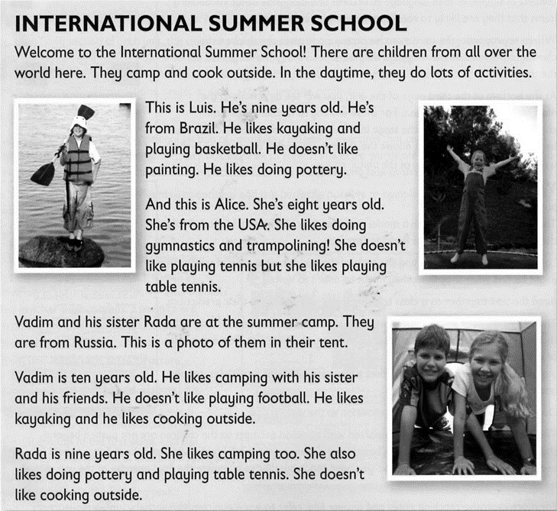
Answer the questions
- What does Luis like doing?_______________________________________________________
- What kind of activity do Luis and Rada like doing ?__________________________________
- Does Alice like doing gymnastics?_________________________________________________________
- What activity does Vadim like doing and Rada doesn’t like doing ? _____________________________
- Do Vadim and Roda like camping?________________________________________________________

- Read and answer using simple past tense: Make these sentences true for you. Use the past simple affirmative or negative form of the verbs in brackets.
- I __________________ (can) swim when I was five.
- Last weekend, I __________________ (do) a lot of homework.
- Five years ago, I __________________ (be) a student at this school.
- Ten years ago, I __________________ (live) in a different town.
- I __________________ (make) my own breakfast this morning.

- Put the words in order to make questions. Then write answers that are true for you.

- homework / how much / last / did / you / night / do / ?

Q: ____________________________________________________________________

A: ____________________________________________________________________

- with / travel / did / to / school / you / who / today/ ?

Q: _____________________________________________________________________

A: _____________________________________________________________________

- best / meet / where / you / did / friend / your/ ?

Q: _____________________________________________________________________

A: _____________________________________________________________________

- first / teacher / who / your / was / English / ?

Q: _____________________________________________________________________

A: _____________________________________________________________________

- you /the last year /Where / study /did / ?

Q: _____________________________________________________________________

A: _____________________________________________________________________
- Comparative and superlative: Complete using the adjective in parenthesis and (the) or (than) where its necessary.

- She is ________________________________________________________ (nice) person I know.
- Computers are ________________________________________________ (cheap) mobile phones.
- Is your brother _____________________________________________________ (tall) you?
- I think Spanish is _______________________________________________ (easy) Japanese.
- Sharks are _______________________________________________________ (big) Whales.

- Be going to /Should/ could: Complete the dialogue: Put in order he words in each sentences.

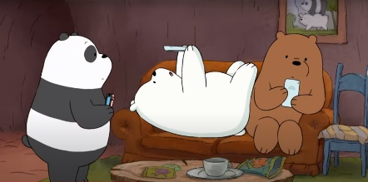
Panda: Oh noo!!! My new cellphone doesn´t have virus protection so is very possible that ( it / stop working/ going to /is)

1. _______________________________________________________________________
Grizzly: Be careful!! I want to use my new cellphone so ( I/ new fans /with/ going to /our / am/chat/ by social networks!)
2. _______________________________________________________________________
Panda: really? Oh; my cellphone isn’t working , Are you going to borrow me your new cellphone?
Ice Bear: I’m sorry, (I/ in my cellphone /going to /am/ install new tools)
3. _______________________________________________________________________
Grizzly : well I finished to chat but watch out!! ( going to /your/ is/ cellphone/ fall down!!!)

4. _______________________________________________________________________
Panda: ohhhh!! and (in few minutes /be /am /going to/I /very mad!!!

5.______________________________________________________________________

- Could /couldn’t / should / shouldn’t: complete the sentences with the right option

- Hello! _____you give me a hand, please?
- Could
- Couldn’t
- Should
- Shouldn’t

- Robert, you are very tired. You _______________ spend so much time in front of the computer!
- Could
- Couldn’t
- Should
- Shouldn’t
- I looked everywhere yesterday and I____________ find my mobile phone. Today it's in the living room!
- Could
- Couldn’t
- Should
- Shouldn’t

- -Let's go to the cinema!
- Yes! Good idea! We ____________see a thriller.
- Could
- Couldn’t
- Should
- Shouldn’t
- This man is not careful. He ______________ wear a helmet.
- Could
- Couldn’t
- Should
- Shouldn’t

